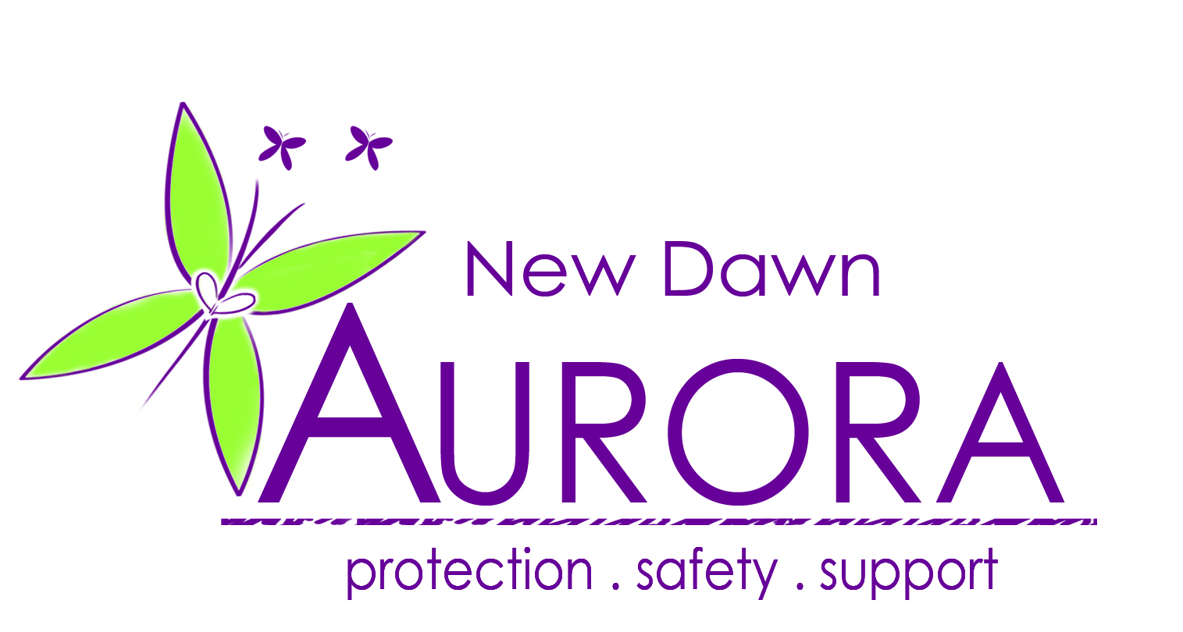

Job Title: Bid Writer
Reports to: CEO Aurora New Dawn
Grade: 9

The Charity

Aurora New Dawn is a local registered charity giving safety, support, advocacy and empowerment to survivors of domestic abuse, sexual violence and stalking.

The Role

The Bid Manager will be responsible for all elements of the bid process, from identification of opportunities through to the production and collation of information, achieving sign-off and final submission.

This is a collaborative role - you’ll be working with colleagues across the charity and will work especially closely with the Senior Leadership Team.

Main duties
- Design and implement bid strategy from start to finish
- Identity bid opportunities, updating a bid calendar for future opportunities and working with key stakeholders to:
Ensure the suitability of opportunities
Evaluating their cost and reward to the business
- Manage the bid process from start to finish
- Be accountable for and manage a central library of tender portal registrations and log-ins
- Create and maintain bid library and proposal templates
- Understand the charities operational, legal, compliance and financial processes, being able to convey them succinctly and clearly
- Planning the bid in conjunction with the CEO
- Identifying and including win themes
- Working on a variety of bids at once
- Compiling relevant supporting documents
- Proofread and edit the documents prior to submission
- Write compelling content and create dynamic visuals
- Gather technical data / supporting documentation from relevant departments and translate the material for the target audience
- Regularly review, update, and improve bid documentation to meet the current needs of the business
- Maintain a portfolio of standardised documentation, for use when compiling written material
- Conduct in-depth customer / industry research to enhance bids for relevant sector
- Help translate technical content/data, so it is clear to the client audience whilst maintaining technical accuracy
- Research and analyse opportunities which are aligned with the company strategy and its values
Key results areas
- The timely and accurate submission of all information and collateral for sales and bids activity.
- As the gatekeeper for all collateral and proposals you will ensure external-facing materials
The Person
To be successful in this role you’ll be a meticulous Bid Manager and writer who is motivated by clarity and direction. You’ll have an innovative outlook and strive to create bids that embody our USPs and company values.

- Previous experience working within a bid role.
- Comfortable voicing your opinions to the leadership team, ensuring we produce a winning bid.
- Be a confident, skilled communicator with strong communication, written and oral skills with experience of proof reading.
- The ability to manage multiple projects, always maintaining an excellent standard of work
- The ability to take full ownership of tasks, be dynamic and driven with the ability to work independently and as part of a team
- Excellent attention to details
- Proficient use of computers, including MS Office
- Proficient in adding leads and converting opportunities as required
- Be computer literate including excel
- Flexibility and willingness to do what is necessary to complete the task to customer bid submission deadlines (this may include additional working hours, but taking the time back suitably as agreed with the CEO)

- Will complete a Disclosure and Barring Service Check (formerly the Criminal Records Bureau and Independent Safeguarding process) as required by all out staff and trustees.

