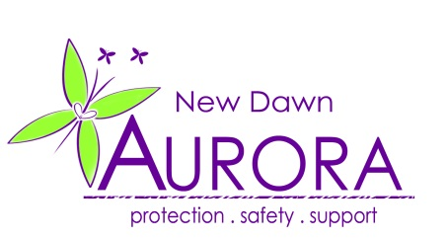

JOB VACANCY

Aurora New Dawn is pleased to announce the following new post:

FEMALE COMMUNITY IDVA (COMPLEX NEEDS) – WEST SUSSEX CONNECT

Hours:

Full-Time: 37 Hours per week

Salary: £22,500 (with 1% annual increment)

Contract Type: Contract until 2021. Continuation subject to funding

Location: West Sussex, working across Crawley & Worthing

Role:

Aurora New Dawn is a registered charity providing support and advocacy to survivors of domestic abuse, stalking and sexual violence.
We are excited to be working in partnership with West Sussex County Council and Safelives to deliver CONNECT: a new and holistic service, created with survivors of domestic abuse and offering a co-ordinated, whole-family response.
We are looking for a skilled, dedicated and passionate individual to take on the role of Community IDVA within the Connect model, working specifically with victims of domestic abuse who have complex or multiple needs. The successful candidate will:
- Deliver a flexible, holistic approach that is personalised for each individual, addressing any risks and improving outcomes around their safety, needs and wellbeing.

- Work in a way that is trauma-informed and solution-focused, undertaking a holistic assessment of need with each client which incorporates an understanding of the prevalence and impact of trauma and the complex paths to healing and recovery.

- Focused on identifying strengths and work towards building resilience.

- Develop and deliver a proactive response that takes the service to clients, increasing opportunities for engagement.

All roles within the Connect team will work in accordance with the 7 key principles underpinning the Connect Model:
- Flexibility, consistency and reliability
- Accessibility
- Strengths-based
- Client involvement
- Gender-responsive
- Working together
- Trauma-informed

To apply:

For further details on this vacancy and guidance on how to apply, please download a copy of the job pack, which includes a full job description and person specification.

For a discussion about the role, or for any queries, please contact Zoe Jackson (Operations Manager) on 023 93 878992

Closing date for applications – 6pm on Tuesday 17th July 2018 .

Interviews will be held on Thursday 26th July 2018

* In accordance with schedule 9 (Part 1) of the Equality Act 2010

