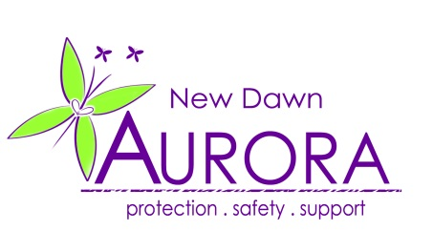

JOB VACANCY

Aurora New Dawn is pleased to announce the following new post:

ARMED FORCES ADVOCATE

Hours:

Full-Time: 37 Hours per week

Salary: £22,221 - Unaccredited
£26,276 - On completion (or prior attainment) of relevant role-related Accreditation

Duration: Commences ASAP. Contract until March 2021, continuation subject to funding.

Location: Portsmouth-based with regular local travel

Role:

Aurora New Dawn is a registered charity providing support and advocacy to survivors of domestic abuse, stalking and sexual violence.
We are looking for an enthusiastic and dynamic individual, with an understanding of the specific needs or armed forces personnel and/or their families, to join us in the launch and delivery of an exciting new project. The Armed Forces Advocate will:

- Provide high-quality support to victims (16+) of domestic abuse, sexual violence and/or stalking, working specifically within an armed forces remit.

- Work closely with our armed forces partners, and within a multi- agency framework, to identify and assess the risks and needs of our clients

- Deliver a pro-active, short to medium term crisis intervention service through individual safety planning and personal support

- Advocate for our clients with relevant agencies, whilst providing emotional and practical support and information, including in relation to legal options, housing, health and finance.

This is a specialist, multi-skilled role, and prior completion of a Domestic abuse, sexual violence or stalking advocacy qualification would be advantageous. However, we would welcome applications from those who feel they have demonstrable equivalent experience/qualifications which meet the specific requirements of this post.

To apply:

For further details on this vacancy and how to apply, please download a copy of the job pack, which includes a full job description and person specification.

For a discussion about the role, or for any queries, please contact Lyn Tiller (Community Projects Manager) on 023 92 479254

Closing date for applications – 6.00pm on Sunday 22nd April 2018 .

